**Searching for string**

**What is a Arrays?**

An array in JavaScript is a data structure that can hold multiple values. These values can be of any data type: strings, numbers, objects, or even other arrays.

1. **Creating Arrays**:

You can create an array in JavaScript using square brackets [ ] and separating each element with a comma.

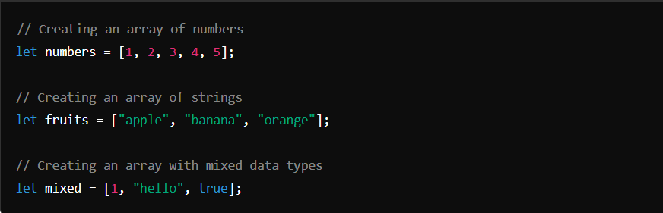

1. **Accessing Elements:**

You can access elements in an array using their index. Remember, array indices start from 0.

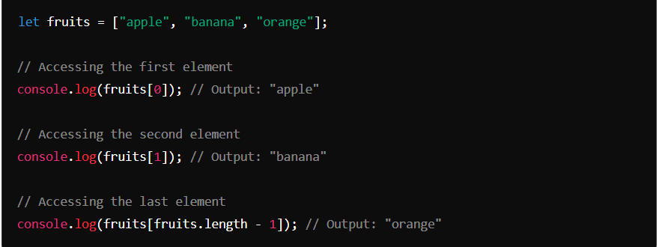

1. **Array Methods**:

**pop() :** Removes the last element from an array.

**shift() :** Removes the first element from an array.

**unshift() :** Adds one or more elements to the beginning of an array.

